Asynchronous and synchronous communications’ effect on user engagement in prediction games

A Thesis

by

JUNNUTULA MEGHANATH rEDDY

Submitted to the Office of Graduate and Professional Studies of

Texas A&M University

in partial fulfillment of the requirements for the degree of

MASTER OF SCIENCE

Chair of Committee, Frank Shipman

Committee Members, Richard Furuta

Susan Pedersen

Head of Department, Dilma Da Silva

August 2015

Major Subject: Computer Science

Copyright 2015 Junnutula Meghanath Reddy

Abstract

Fantasy sports, a medium that engrosses millions of players around the world, increases the player’s expertise and understanding about the domain of the sport. Prediction games, based on the gameplay model of fantasy sports, combine archival data and near real-time data to motivate interaction with domain-specific datasets, thereby providing rich learning opportunities. These games have the potential to engage learners in an exceptional way and provide new learning techniques.

Past research suggests that communication leads to greater commitment and fuels user-engagement in games. By engagement, we mean players’ active participation and involvement with the activities in the game. Consequently, this increases the probability of learning about the domain and data sets embedded into the game in the context of prediction games. However, empirical evidence is sparse regarding the influence of communication in prediction games. This thesis investigates asynchronous and synchronous communication and their influence on player commitment: Forums, Direct Messages (DM), and Message Boards form the asynchronous mode of interaction, and chat/instant message (IM) system are the synchronous mode. A comparative analysis of their use in a prototype prediction game provides insights into the relationships between the different modes of communication and player engagement. Although previous work suggests that social interaction is valuable in increasing commitment and promoting peer learning, little is known about the relative value of different modes of communication. Thus, this research specifically focuses on the influence of different modes of communication in prediction games.

We have conducted a user-study to explore the effect of communication in prediction games. The results indicate that asynchronous communication, particularly in the forum, most effectively engages players. The evaluation also provides insight for improving the game and useful suggestions regarding the design of the communication system. To summarize, overall activity, interaction and player participation increased during the presence of asynchronous communication. Future work could explore the potential for alternate results when players are well known to each other or when game activity is synchronized, as the results point to these constraints as having the greatest impact on the lack of use of synchronous communications in the prototype prediction game.

Dedication

To my Mom, Dad and Sister, for all the love, care and support.

Acknowledgements

This thesis would not have been possible without the supervision and support of several individuals who in one way or the other contributed and extended their valuable assistance in the development of the Fantasy Climate Change game and completion of the user study.

Foremost, I would like to express my sincere gratitude to my advisor, Dr. Frank Shipman, whose encouragement, guidance and support from the initial to the final stage enabled me to accomplish this work. Also, I would like to extend my deep gratitude and respect to my committee members Dr. Richard Furuta and Dr. Susan Pedersen. I would like to thank Dr. Hank Walker for being flexible with my teaching assistant schedule and valuable advice.

I take this opportunity to thank Gabriel Dzodom, Sampath Jayarathna, Caio Duarte Monteiro, Satya Kiran, Akshay Kulkarni, Saketh Ram, Joshua Sheehy and Suinn Park for their helpful suggestions and insightful comments.

Nomenclature

FC Fantasy Climate

Table of Contents

Page

Abstract ii

Dedication iv

Acknowledgements v

Nomenclature vi

Table of Contents vii

List of Figures ix

List of Tables xii

Chapter I introduction 1

1.1 Fantasy sports 2

1.2 Why do people play games? 4

1.3 Engagement in games 6

Chapter II literature Review 9

2.1 Asynchronous communication 10

2.2 Synchronous communication 12

Chapter III fantasy climate application 15

3.1 Login 17

3.2 Homepage 18

3.3 Registration 19

3.4 News board 20

3.5 Profile 21

3.6 Miscellaneous 21

Chapter IV fantasy climate gameplay 23

4.1 Pre-activity 23

4.2 Activity 23

4.3 Post-activity 34

Chapter V user study 36

5.1 Demographics 36

5.2 Protocol 37

5.3 Web analytics 41

Chapter VI evaluation and results 43

6.1 Pre-questionnaire 43

6.2 Gameplay 47

6.3 Post-questionnaire 58

Chapter VII Conclusion and future DIRECTION 68

References 70

appendix-1 74

appendix-2 79

List of Figures

Page

Figure 3.1. Operating system analytics from user study for group having asynchronous communication first (top) and group having synchronous communication first (bottom). 16

Figure 3.2. Browser analytics from user study for group having asynchronous communication first (top) and group having synchronous communication first (bottom). 17

Figure 3.3. Login page. 18

Figure 3.4. Navigational header of the homepage. 18

Figure 3.5. Homepage before the start of the activity. 19

Figure 3.6. Registration page. 20

Figure 3.7. Profile view page. 21

Figure 4.1. Pre-activity homepage. 24

Figure 4.2. Activity homepage with all the features. 25

Figure 4.3. Fantasy climate ’15 showing the activity details. 25

Figure 4.4. Thermovizz tool showing the historical averages. 27

Figure 4.5. Chat system in the game. 28

Figure 4.6. Forum from the user study. 29

Figure 4.7. Prediction page. 30

Figure 4.8. Prediction page showing cities, previous and current entries. 31

Figure 4.9. Scoreboard from the user study. 32

Figure 4.10. (a) Overall achievement board (b) individual prediction achievement. 34

Figure 4.11. Post-activity homepage. 35

Figure 5.1. User study plan. 39

Figure 5.2. City cluster 1. 40

Figure 5.3. City cluster 2. 40

Figure 5.4. City cluster 3. 41

Figure 6.1. Experience playing fantasy sports in years. 43

Figure 6.2. Number of hours spent playing fantasy sports in a week. 44

Figure 6.3. Motivation to play games in general. 45

Figure 6.4. Users’ interest in following news related to climate/weather. 45

Figure 6.5. Users’ familiarity with simple data analysis. 47

Figure 6.6. Page views for group-1. 49

Figure 6.7. Unique page views for group-1. 50

Figure 6.8. Average time on pages in minutes for group-1. 51

Figure 6.9. Average session duration in minutes for group-1. 51

Figure 6.10. Number of sessions for group-1. 52

Figure 6.11. Number of pages/session for group-1. 53

Figure 6.12. Page views for group-2. 54

Figure 6.13. Unique page views for group-2. 55

Figure 6.14. Average time on pages in minutes for group-2. 56

Figure 6.15. Average session duration in minutes for group-2. 56

Figure 6.16. Number of sessions for group-2. 57

Figure 6.17. Number of pages/session for group-2. 57

Figure 6.18. Participants’ responses about overall communication system based on a likert scale (1 to 5). 60

Figure 6.19. Participants’ experience with the forum based on a likert scale (1 to 5). 61

Figure 6.20. Participants’ experience with the message board based on a likert scale (1 to 5). 62

Figure 6.21. Participants’ experience with the direct messages based on a likert scale (1 to 5). 63

Figure 6.22. Participants’ experience with the chat based on a likert scale (1 to 5). 63

Figure 6.23. Overall comparative analysis of forum, message board and direct messages. 64

Figure 6.24. Activity in terms of (a) number of messages and (b) number of words on the communication systems. 66

Figure 6.25. Type of messages on the communication systems. 67

List of Tables

Page

Table 6.1. Participants’ rating of the overall communication system based on a Likert scale (1 to 7). 59

Chapter I   
introduction

It is well established that games can engage learners and improve understanding. Interactive game features along with intriguing content can engross users and achieve desired instructional goals (Garris, Ahlers et al. 2002, Davies and Graff 2005, Habgood and Ainsworth 2011). In educational games, the relationship between winning the game and learning the domain are often harmonious and mutually supportive. Thus, the games’ enthralling components and model are expected to increase learning. In addition, experiential evidence exists that games can be an efficient mechanism for learning and understanding of complex subject matter (Cordova and Lepper 1996).

One of the primary motivations to play games is social interaction. Games have always nurtured social activity and fostered collaborations (Kappen, Gregory et al. 2013). In this thesis, we discuss two modes of communication and their effect on gameplay. Synchronous communication enables real-time interaction and collaboration in a "same time-different place" mode. For example, the chat/IM system added to our game allows two people to connect at a single point in time and possesses the ability to engage people instantly. On the other hand, asynchronous communication enables collaboration over a period of time through a "different time-different place" mode. The main advantage is that people can connect and communicate at their convenience. In addition, asynchronous systems like forums and message boards are helpful in recording the history of the interactions of a group, allowing for collective knowledge to be more easily shared and distributed (Cordova and Lepper 1996).

Our research group is designing, developing, and evaluating prediction games: games in which players predict outcomes in a domain based on their understanding of historical data. Prediction games can be developed for any domain with historical data and real-time data to nurture engagement and learning about the domain. Prediction games have the potential to play an important role in an educational setting since they emphasize the development of data interpretation skills and mental models of the domain. Fantasy sports, which combine historical data on athletes’ performances with real-time data generated from live sports events (Holleman 2006, Boswell 2007, Ruihley and Hardin 2011) are a subset of prediction games. We speculate that the successful traits of fantasy sports may be generalized to prediction games in other, more “serious”, domains.

This section describes about fantasy sports, motivations for playing games, and engagement in games. Further sections include related work, implementation of the Fantasy Climate game, features and gameplay. The thesis concludes with an evaluation of the user study and contributions of this research.

1.1 Fantasy sports

Fantasy sport is an interactive team-management activity based on statistics accrued by athletes of real-life professional sport organizations and college athletics (Shipman 2009). Fantasy sports are a game of skill, requires the players to consider countless number of statistics, facts and game theory in order to excel and be competitive (Holleman 2006). The player selects a fantasy team of their choice by considering the real-time statistics like the manager of the real sport. After each event, the statistical performance is converted into points that are amassed according to the player’s fantasy team. Consequently, the manager can change the composition of the team by transferring and trading players. Similar to the real game, the players are constrained by virtual currency and limited transfers within the game. Among the many factors that motivate the fantasy sport players, competition and challenge play an important role in keeping them engaged with the game (Ruihley and Hardin 2011). In order to succeed and maximize points, a player must be acquainted with the real sporting events and make changes to the team accordingly. In order to be a successful manager, the player must consider a lot more than simple analysis techniques and statistics to conquer the league; they also must to take into account coaching styles, future prospects, home and away statistics, injuries, etc.

Fantasy sport is immensely popular all over the world with participation growing since its origin in the 1950s. According to Fantasy Sport Trade Association, 42 million people in the U.S. and Canada played fantasy sports in 2014. With major technology companies and sports organizations like ESPN, Yahoo, NBC, CBS, MLB, NFL, and etc. launching their own fantasy games on the Internet, the fan base and reputation has increased tremendously over the past few years. With the intervention of technology and increasing popularity, fantasy sports has branched out to include non-sports related games focused on politics, sales, celebrity gossip, movies, and reality TV.

Prior research suggest that the people improve their knowledge about the domain of the fantasy sports with enduring involvement in the game.

1.2 Why do people play games?

Millions of people play online games around the globe. It is important for us to know the motivations to play games before analyzing the effect of communication in prediction games. The three main components that motivate people to play games are achievement, socialization and immersion (Yee 2006). Often times when people achieve goals or overcome a challenge in the game, they satisfy their inherent hunger to succeed and fulfill their inclination towards competence. Sometimes people play games to accomplish their desire to feel successful in life. Simulation games have also shown to increase a person’s ability, character and hone fine motor skills. Studies show that first-person shooter games increase the player’s visual perception and dexterity (Selnow 1984, Olson 2010). Some of the reasons people play games are explained as follows:

1. *Entertainment and Fun* - This is the most common reason people turn to games. Games ranging from simple board to complex arcade games have many fun-creating elements in them that entertain all age groups and people all over the world.
2. *Competition and Challenge* – The desire to challenge and battle with others also motivates players. In addition, people like to solve perplexing puzzles, dominate different aspects of the game and master the complexity.
3. *Escapism* – People turn to games to escape the boredom of real life, relieve stress and as a casual pastime.
4. *Social Experience* - The desire to form good relationships through the game and socialize with fellow players is another important reason motivating people to play games. The next section explains the importance of social activity especially in education games.

1.2.1 Social activity in games

With the advent of interactive games in social networking sites like Facebook and Raptr, the popularity and acceptance of social games has enormously increased. Social interaction in education games allows players to share valuable information and exchange knowledge. Also, it is essential in increasing commitment and keeping players engaged in group activities (Dabbish, Kraut et al. 2012). Past research also suggests that communication between members of a group is also strongly related to the level of commitment. In a gaming environment, people tend to use built-in social tools to discuss strategies and socialize with their competitors. Often, these social ties are known to extend beyond the game. In many contexts, people enjoy games more when playing with other people than when just playing with the computer (Gajadhar, De Kort et al. 2008). Social presence motivates people to play longer, thereby allowing more interaction and engagement with the game. In an educational context, these collaborations can be important to increase learning of the domain.

The purpose of this thesis is to investigate the effect of different modes of communication on user engagement and social interaction in prediction games. In addition, it may provide insight into how those effects influence data skill development and domain learning.

1.3 Engagement in games

Engagement is an important factor to gauge the player’s experience in games. Hence, it is one of the crucial factors for game designers and developers to consider while creating games. Player engagement in a gaming context can be defined in terms of players’ desire to continue playing. In one study, it is defined as minimum amount of involvement a player must experience before being completely immersed or engrossed (Brown and Cairns 2004). Moreover, there is subtle difference between motivation and engagement in games. Motivation as described in earlier section explains why people start to play games and the various factors that keep them playing overtime. Engagement is more concerned with what affects players’ intensity of play.

Although we do not have a universal methodology or questionnaire to measure engagement, some of the important contributing factors are immersion, flow, presence and absorption (Fox and Brockmyer 2013).

*1.3.1 Immersion*

Immersion is a figurative term that has originated from being drenched in water. Similar to the metaphorical meaning, immersion in a gaming context refers to the feeling of being involved in the game. Finally, the players forget their surroundings in the final stage of immersion.

*1.3.2 Flow*

Flow is defined as a state where one completely engages with the game, thereby losing track of time. In this situation, the players plays longer than usual due to the various captivating features of the game. Also, it is used to describe the feeling of enjoyment that occurs when an individual solves a challenging task in a gaming environment.

*1.3.3 Presence*

It is defined as the state of feeling the virtual gaming environment and the competition although being in the regular state of mind. Recent studies also show that a rich social environment enhances player enjoyment mediated by social presence (Schoenau-Fog 2011).

*1.3.4 Absorption*

It is an altered state of consciousness where a separation of emotions, feelings, thoughts and experiences occur within the game from the real world. In this state, the player tends to feel the virtual gaming world more than the real world.

Although prediction games do not contain all the features needed to engage people in the same way as other multimedia games, some of the factors mentioned above can be considered to measure engagement in our Fantasy Climate Change game. Technological evolution has bridged the gap between e-learning, gaming and computing. Engaging games have the potential to provide an excellent learning platform and constantly impart knowledge to the players. Our motive through this thesis is to analyze the communications’ effect on player engagement in prediction games. This would provide future designers measures of communication systems’ effects on player engagement. Furthermore, a comparative analysis between the use of asynchronous and synchronous modes of communication in prediction games may identify trade-offs between in-game communication approaches.

Chapter II  
literature Review

Over the past few years, the effect of communication in various fields has been researched in great detail both hypothetically and experimentally. Games have always been an activity that build social connections among players which is often missing in public spaces and develop an individual’s personality (Kappen, Gregory et al. 2013). These mixed collaborations provide flexible learning methods and a cordial playing experience. Players have a better experience playing the game and enjoy it more when they play with a friend than with the computer (Mandryk and Inkpen 2004). Having fun together and building deeper relationships were stronger motivations than winning the game to some of the players (Xu, Cao et al. 2011). Even the most violent games, which are portrayed as anti-social, can foster harmonious relationships. The success of multiplayer games from the standpoint of social activity can be gauged from the levels of interaction and collaboration that occur during and around gameplay. Besides the capabilities for social interaction built into the games, people seek extrinsic supports and other workarounds to socialize (Manninen 2003). As engagement and social activity are important elements of player experience (Schoenau-Fog 2011), it is important for the game designers to know what factors influence engagement and promote collaboration within the game.

        According to a study by Schoenau-Fog (2011), people return to play games having an in-built communication system because it spurs friendship, togetherness and companionship. Also, players who provide support in the game and perform well earn the respect of other players, thereby advocating engagement. However, one study reports that people enjoy soloing as it is challenging, but they again find temporary allies to chat with, which makes it a communal activity (Nardi and Harris 2006).

        In social games, the most frequently used form of communication has been the wall post, an asynchronous form of communication (Consalvo 2011). Although, players can initiate a wall post, game designers prompt players to engage via these posts. Games like YoVille, Dragon Age Legends, We Doodle and Cooking Mama assume asynchronous communication as being important to the gameplay-community. More generally, both asynchronous and synchronous channels have been used to foster communication in games. Both these channels of communication enhance the in-game experience and provide intrinsic forms to socialize amongst each other.

2.1 Asynchronous communication

Socialization has an important influence on the decision to participate in fantasy sports as discussed earlier. It can occur in person, or via the use of communication tools such as messages boards, forums, email, and blogs.

A message board is a social tool where people post and read messages, generally on a precise topic or area of interest. Being an asynchronous social tool, participants can use it irrespective of propinquity and time constraints. A study examining the difference between message board users and non-users shows that message boards enhance fantasy sport experience (Ruihley and Hardin 2011). Additionally, their analysis showed that surveillance, logistical conversation, socializing, and eliciting advice or opinions were the main motivations behind message board usage. The structure is similar to the wall posts discussed earlier in this section, but the message boards allow the content to be shared amongst all the players in the game.

Another study found that users convey feelings, thoughts and emotions on the message board (Woo, An et al. 2008). Message boards also help the public relations practitioners of the fantasy sport to analyze the popularity of the organization among the players and gauge their current status. From the previous studies, it is evident that the message board users have higher overall satisfaction and engagement with the game than non-users.

In today’s education system, online dialogue between students and instructors has become a common phenomenon as a part of the coursework (Hew, Cheung et al. 2010). Hence, the use of forum in online learning environments is widely acknowledged, and considered to be extremely beneficial in sharing knowledge (Rovai 2002) (Bradshaw and Hinton 2004). The participation in these online discussion forums and collaborative learning has positively contributed to the students’ success (Pieterse and van Rooyen 2011). In fact, Nandi et al. (2011) reported a positive correlation between the times spent on online discussions and the students’ grades. Biggers et al. (2009) found that students spend more time on class objectives when they actively participated in forums and socially interacted with their peers.

Some of the other benefits of the forum include improved student performance, promoting an online community and enhanced relationship between the instructor and student. Loneliness and solitude in students, one of the problems prevailing in today’s society can be successfully eliminated by fostering an online community (Burns 1991). Although students do not visit the forum and post actively throughout the semester, one study shows that students who participate actively achieve a higher grade (Nandi, Hamilton et al. 2011). However, effective participation in the online discussion and collaborative peer learning might not be the only factor effecting the grade.

On the other hand, previous research shows that developing an excellent forum or message board with cutting edge technology and features will not engage the participants all by itself (Guldberg and Pilkington 2007). The moderator plays an important role in stimulating harmonious asynchronous discussions and encouraging cordial interaction amongst the participants (Andresen 2009). Questions and topics in the asynchronous discussion are more likely to emerge progressively once the peer relationships have developed.

It was found that some students prefer to work alone as problem-solving conversations can be difficult to hold in an asynchronous environment (Oliver and Omari 2001). For instance, extremely specific questions like ‘what am I missing to solve the problem’ cannot be answered and explained with mere text.

2.2 Synchronous communication

Synchronous communication within the context of games takes the form of in-game or out-of-game chat, audio, or video connections. Chat has become an interactive medium of communication in various environments such as corporate workplaces and social networks. Recently, its importance and value has been recognized in the educational domain as well. Text communication is becoming an important communication tool in the workplace for both informal and formal conversations (Isaacs, Walendowski et al. 2002) and multiple studies have delineated the use of instant messaging in various scenarios (Handel and Herbsleb 2002, Isaacs, Walendowski et al. 2002).

As the workplace is a more formal environment, users tend to be targeted in their communication and satisfy their current requirement in using any medium. A difficulty in the case of group chat is that there might be difficulties interpreting successive messages during rapid conversations (Garcia and Baker Jacobs 1999). Such issues are likely inevitable when dealing with multiple people and conversations synchronously. Hence, design of the particular interface is an important issue in a synchronous setting. Additionally, it was found that use of synchronous system focused on important work-related tasks, socializing with peers and scheduling meetings.

In games, chat has been primarily used to socialize and build relationships with other players. A study conducted on StarCraft II revealed that the in-game synchronous text supported the communications necessary to play the game (McClelland, Whitmell et al. 2011). Although the focus of that study was on real-time games, the effect of synchronous communication may extend to data games. The study findings revealed that players prefer communication tools that provide both robustness and adaptability.

The synchronous chat tool increased ease of contacting other players, affiliated the gameplay experience, and facilitated casual, yet valued conversations. In spite of these advantages, players reported that the tool did not cater to the overall social requirements in the game. Each game may result in alternate communication needs and opportunities. It is not possible to integrate all communication tools into games, so game designers must consider the specific needs of the players to foster interaction.

Fantasy sports have shown to increase the player’s knowledge and understanding about the domain of the sport being played. The results from one study show that the model of fantasy sports, indeed, can be used as a medium to motivate people to learn more about weather and climate data (Dzodom and Shipman 2014). Similarly, this can be generalized to any data domain and enhance a players knowledge though fantasy games. It has also been found out that this kind of educational activity will motivate people to learn about the data domain and provide innovative learning methods (Rohit 2013).

Chapter III  
fantasy climate application

The Fantasy Climate game is a web application that is created with a browser-supported programming language (such as the combination of JavaScript, HTML and CSS) and relies on a web browser to render the application. Being a web application, the game is universally accessible to all players having a stable Internet connection. Dynamic web pages were created using PHP, an open-source server-side scripting language along with the support of MySQL database. The Representational State Transfer (REST) architectural style has been used to implement the web service. In the REST architecture, data and functionality are considered resources and are accessed using Uniform Resource Identifiers (URIs), typically links on the Web. JAVA was used to implement the back-end functionality and core properties. The web client was developed using popular web technologies like JavaScript, CSS3 and HTML5. Bootstrap, a front-end framework has been used to design HTML- and CSS-based templates for typography, forms, buttons, navigation and other interface components.

All of the above mentioned technologies are freely available and require no permissions to be used. The Fantasy Climate game has been designed as a platform independent application, and thus would efficiently work across Linux, Windows and Mac OS having an HTML5 enabled web browser to support the content rendering. While the details of the user study will be presented later, Figure 3.1 shows that even within a small fielding of the game a variety of platforms were used by the participants.

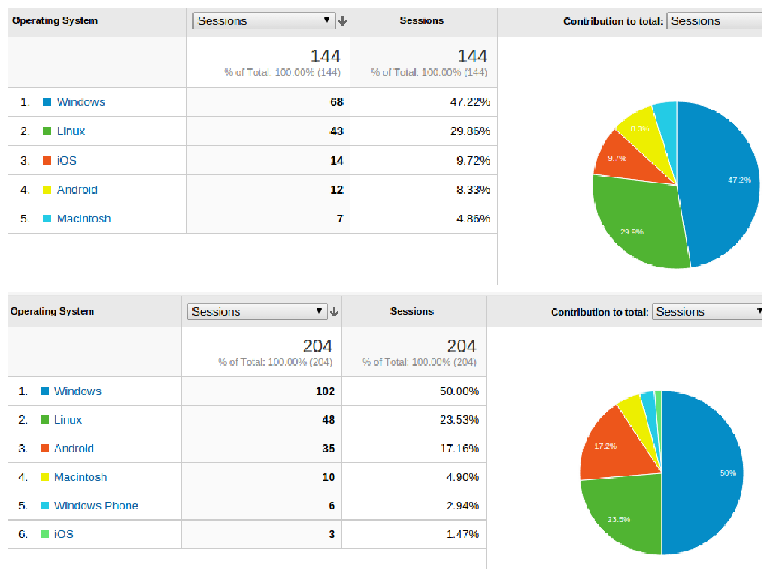

Figure 3.1. Operating system analytics from user study for group having asynchronous communication first (top) and group having synchronous communication first (bottom).

The inclusion of the Bootstrap library makes the application adapt to a variety of screen sizes and browsers. Although we have developed and tested the application as a desktop interface, it adjusts to most tablets and smart phones (iOS and Android) having an HTML5 enabled mobile browser as shown in Figure 3.2. Thus, our application’s accessibility ranges to various devices. This chapter and the next describes the players’ interaction with the interface and server. I have implemented the following components of the larger system:

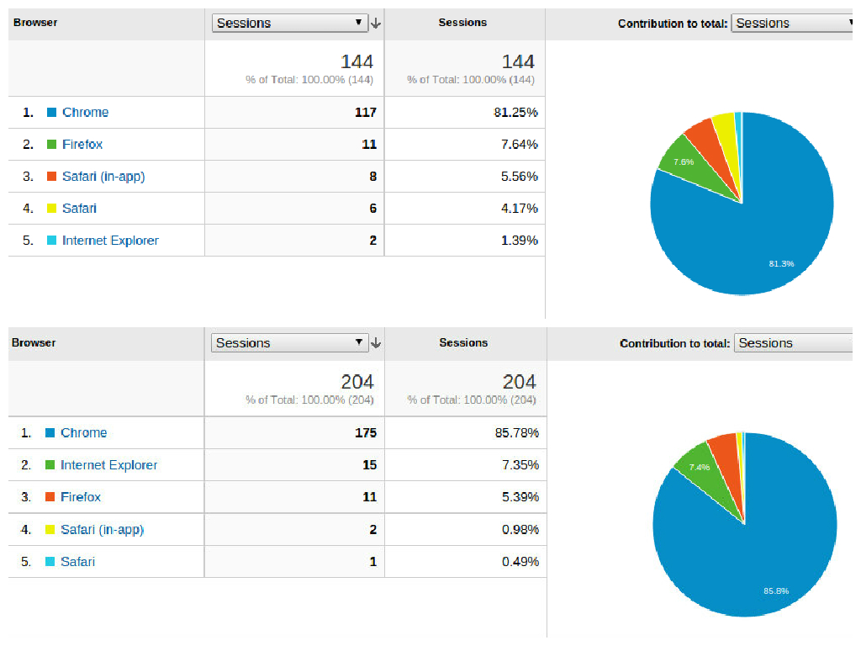

Figure 3.2. Browser analytics from user study for group having asynchronous communication first (top) and group having synchronous communication first (bottom).

3.1 Login

The Fantasy Climate game includes familiar features of many other web applications to the users. Players are initially directed to the login page as shown in Figure 3.3 and forced to enter their credentials to open a session or play the game. They will be asked for general details like email and password to log in. As a security measure, the password and email are encrypted using a jQuery plugin (sha256) in order to avoid the exposure of confidential information.

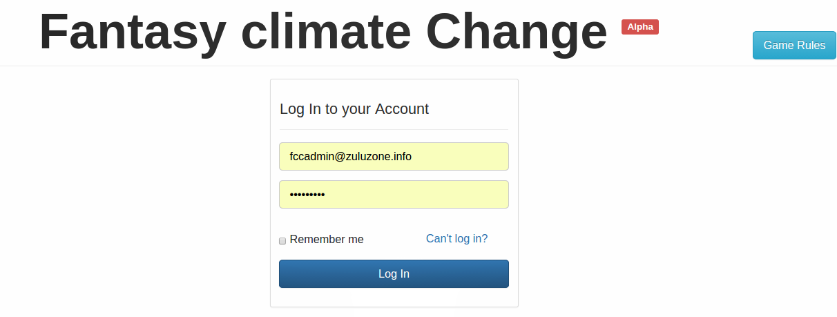

Figure 3.3. Login page.

3.2 Homepage

Once the user successfully logs in, they will be directed to the homepage of the application. On the top of the homepage, a navigational header bar provides all the options the user can access before the start of the activity as seen in Figure 3.4. The homepage in different activity states will be clearly explained in the next section. Moreover, the header, rules and logo will be accessible throughout the system on all the pages. As seen in Figure 3.5, the left part of the body consists of an activity tab showing the status of the current game and whether the player need to do something and by when. Over to the right is the news tab which pulls up the latest news from the news board.



Figure 3.4. Navigational header of the homepage.

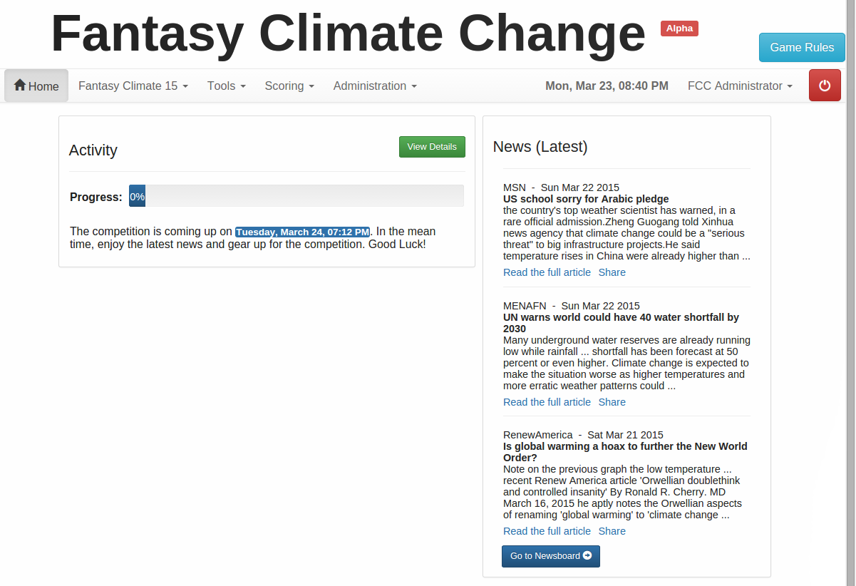

Figure 3.5. Homepage before the start of the activity.

3.3 Registration

In order to register, it is mandatory to provide the corresponding information as shown in Figure 3.6. Form validations are implemented to ensure all the information is filled thoroughly. Private information is encrypted and securely saved in the database. Once the account has been created and checked for potential duplication in the database, a notification consisting of the login details is sent to the provided email and the user is redirected to the login page.

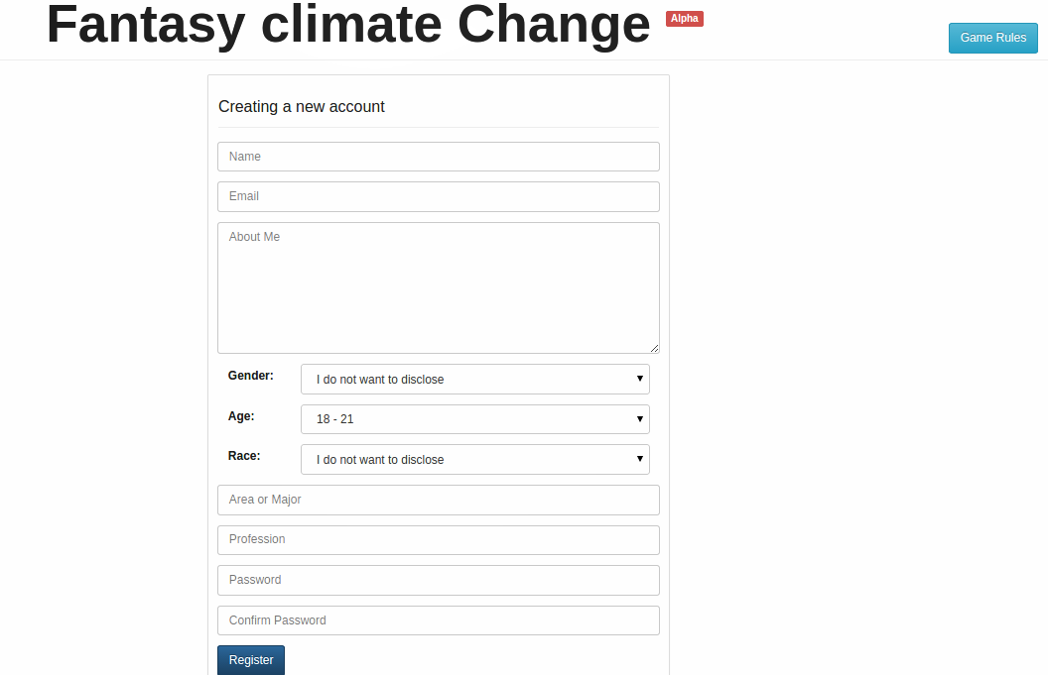

Figure 3.6. Registration page.

3.4 News board

As the name suggests, this page loads the news from the Internet according to the frequency set by the administrator. The activity news filters are specifically set to load news related to climate, current temperatures and weather forecast. Currently, the game draws the news from Bing and the New York Times. This page also supports the feature of sharing the news snippets with the competitors and fellow players. This ability was added to promote engagement and support interaction within the game.

3.5 Profile

A profile picture plays an important role in online games and provides a means for self-expression in order to form social, geographical, and political connections (Hum, Chamberlin et al. 2011). Hence, our game gives users the capability to edit their personal information and profile picture. This is depicted in Figure 3.7.



Figure 3.7. Profile view page.

3.6 Miscellaneous

The Fantasy Climate game also includes other pages like password reset, edit profile, etc. The climate data is downloaded periodically from the Weather Underground website (<http://www.wunderground.com>) into the server-side database using automated scripts. Also, the notification system is scripted to send email reminders about predictions, scoring and other communication to fellow competitors. The frequency of notifications can be monitored while setting up the activity in its initial stage.

Chapter IV  
fantasy climate gameplay

The fantasy climate game currently supports one activity or league at a time and all the players compete against each other within the same activity over a duration defined by the activity’s administrator.

4.1 Pre-activity

Before the game begins, the participants who are part of the activity have access to the activity details, the cities available to be chosen for the current prediction, and a player directory. Also, they can update their profiles and read the news. This phase allows the players to become familiar with the game, scoring formulas, data properties and features. The homepage before the activity begins is shown in Figure 4.1. As seen in Figure 4.3, they can view activity details like prediction due and scoring dates, cities, and a description of the activity, data properties and scoring formulas even before the start of the activity.

4.2 Activity

When the game is active, the participants have access to an extended set of tools and features as decided by the administrator. Figure 4.2 shows the homepage when the game is active. To play the game, players need to predict the hottest city whose high temperature deviates the maximum from the historical average high temperature and the coldest city whose low temperature deviates the maximum from the historical average low temperature. The activity details are depicted in Figure 4.3.



Figure 4.1. Pre-activity homepage.

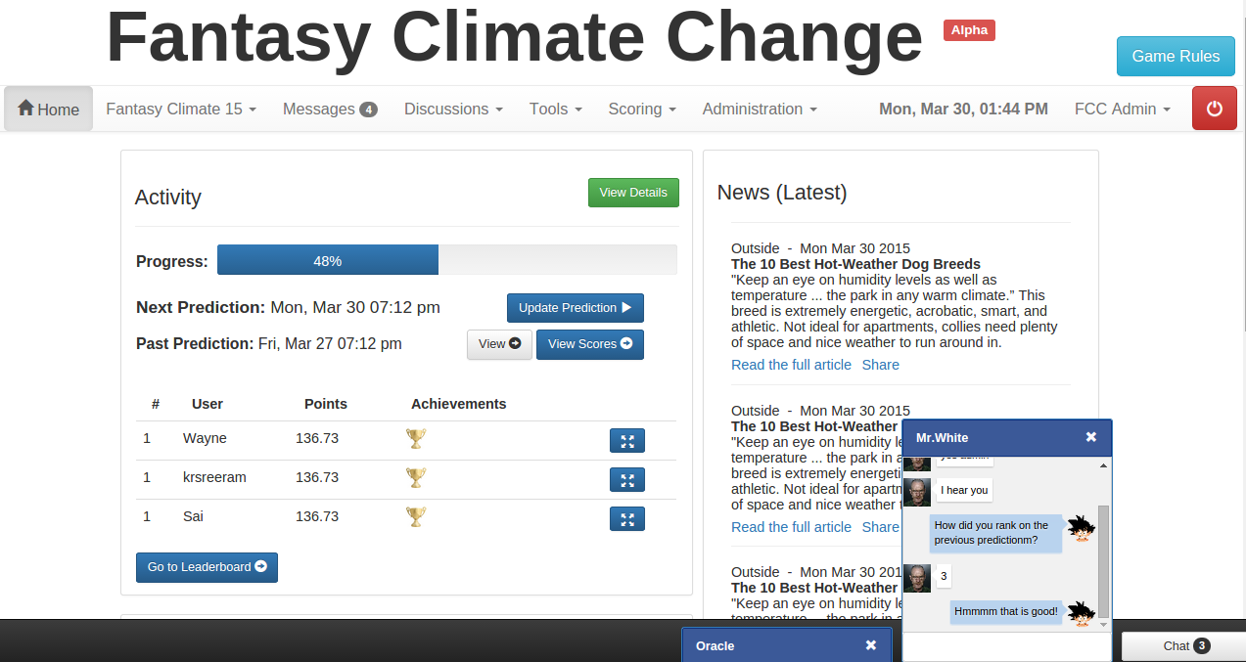

Figure 4.2. Activity homepage with all the features.

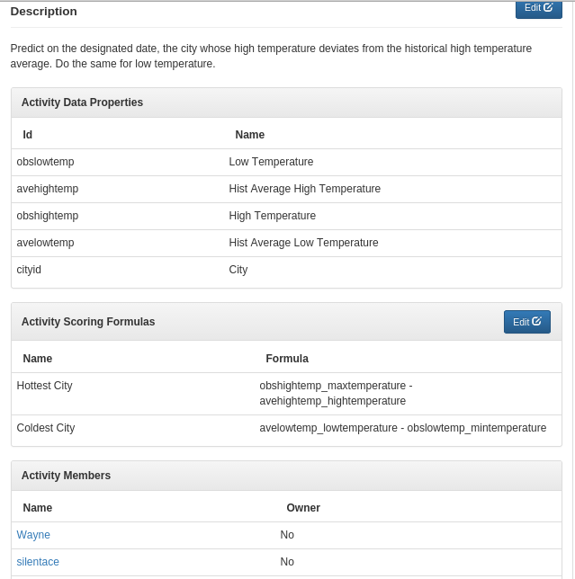

Figure 4.3. Fantasy climate ’15 showing the activity details.

In fact, the main objective is to examine the historical data and develop an interpretation of the patterns in that data that supports successful predictions. The tools and features of the game in the active state are explained as follows:

4.2.1 Thermovizz

Thermovizz is a component of the Fantasy Climate game that provides access to and visualization of historical data. In particular, Thermovizz presents graphs of historical high and low temperatures for every two years starting from the year 1950. The only exception was the year 2000 as the data was corrupted. Thermovizz is shown in Figure 4.4 presenting the high temperatures in Buffalo, New York and Phoenix, Arizona for the 5th of April.

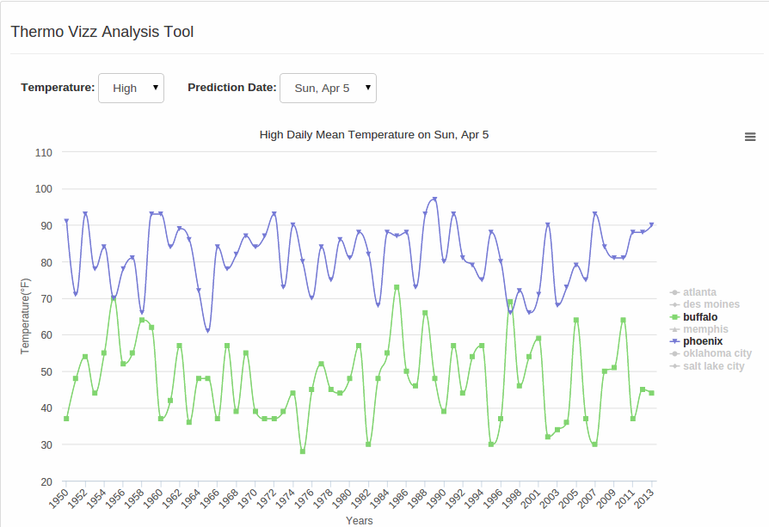

Figure 4.4. Thermovizz tool showing the historical averages.

4.2.2 Communication system

As previously described, communication among members of a group or organization is essential in increasing commitment and keeping them engaged in group activities. Different forms of communication have been adopted and are valuable in different games. In Fantasy Climate, users have access to two modes of communication in this game as permitted by the administrator: synchronous and asynchronous.

4.2.2.1 Synchronous

Synchronous communication supports real-time intercommunication and corroboration in a "same time-different place" mode. For example, the system allows people to chat that is to send short text messages to other players. However, synchronous communication is often inconvenient as it requires the users to be online concurrently. Figure 4.5 shows the chat system when the game is active.



Figure 4.5. Chat system in the game.

4.2.2.2 Asynchronous

Asynchronous communication enables association over a period of time through a "different time-different place" mode. The main advantage is that people can connect and communicate at their convenience. In addition, asynchronous systems like forums and message boards are helpful in recording the history of the interactions of a group, allowing for collective knowledge to be more easily shared and distributed. Again, in Fantasy Climate, all the players have access to all forums and messages once they login as decided by the administrator. The forum from a real user study is shown in Figure 4.6.

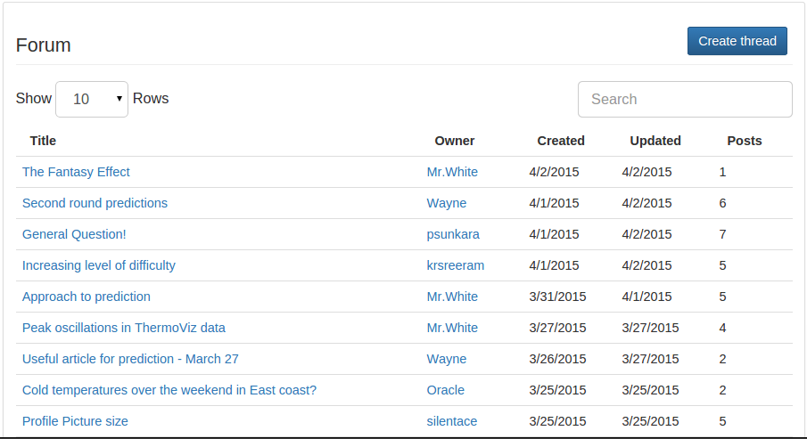

Figure 4.6. Forum from the user study.

4.2.3 Prediction

The prediction page allows the user to submit current predictions and to view their past predictions. The activity requires the players to select one city as the “hottest” and one as the “coldest”. Scoring was based on how much hotter (or colder for the “coldest”) the selected city was on a particular date compared with the average of the high (or low) temperatures for that city on the same date between the years 1950-2013. To predict hottest city, the user selects their choice of city on the map and clicks on the up arrow or the red pop up. Similarly the user predicts coldest city. Once the users finalize predictions, they submit them by clicking on the ‘Submit Prediction’ button which stores the current selection in the database securely. Players may update their predictions any number of times before the deadline for the current prediction.

As shown in the Figure 4.7 and 4.8, the list of available cities is placed to right of the map for convenience and better visualization. In addition, the data analysis tool is placed on top of the map to encourage users to visit the Thermovizz analysis tool before they submit their prediction.

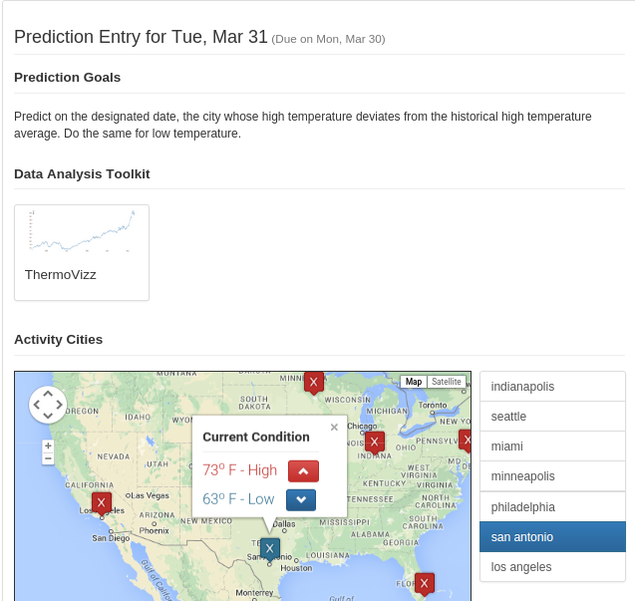

Figure 4.7. Prediction page.

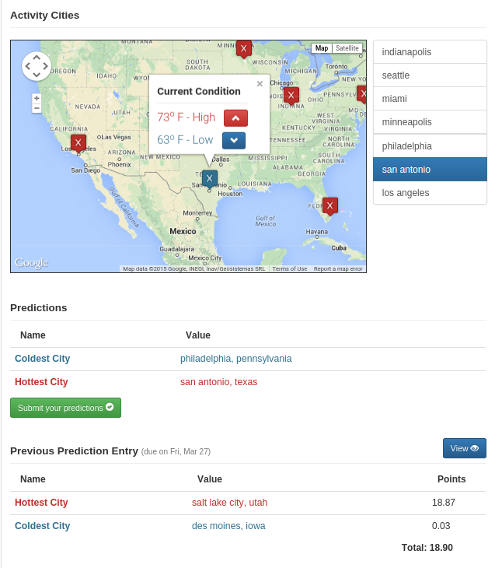

Figure 4.8. Prediction page showing cities, previous and current entries.

4.2.4 Score board

Prior research shows that competition drives people to initially play online games, interact with one another, and increase the engagement with the game. Moreover, players who encounter competition (a winning or losing condition) replay or engage with the game more than the ones who do not experience challenges within the game. Although several factors may affect the player’s engagement to the game, success relative to other players is proven to affect the player’s perception of fun (Charles, Kerr et al. 2005). Hence, it is important to readily depict the scores and achievements at the end of each prediction.

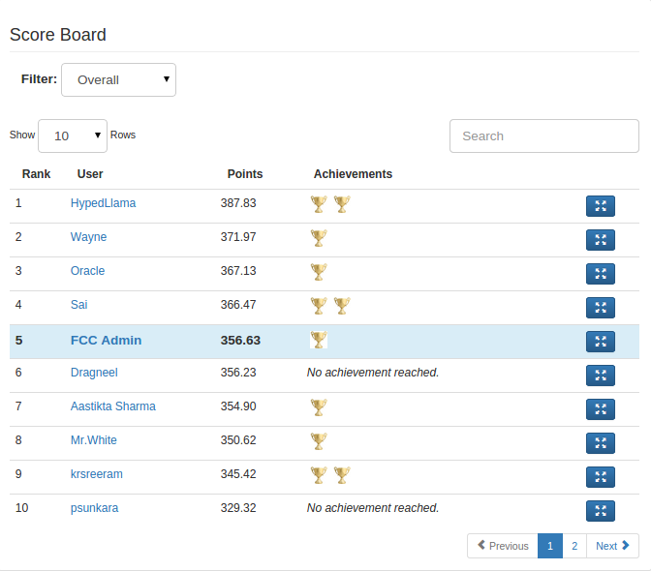

Figure 4.9. Scoreboard from the user study.

We have embedded an interactive leaderboard into the game to promote competition among the players. The player can easily switch between the overall and specific prediction phase scores. The scoreboard shows the individual points and achievements unlocked after each prediction. Figure 4.9 shows the scoreboard.

4.2.5 Achievement

It is a common practice in online gaming environments to show achievements as badges or trophies.  Also, awarding badges, trophies and ribbons has also become an important factor in “gamifying” online media experiences (Antin and Churchill 2011, McDaniel, Lindgren et al. 2012).  Furthermore, achievements in the form of badges increase player satisfaction and motivation to play the game when committed to targeted online tasks (O’Donovan 2012). Hence, the Fantasy Climate game follows a similar approach representing achievements as badges. Although, we only have one badge as seen in Figure 4.10 awarded to the winner in each prediction for each round, the achievement system can be expanded further by adding entries into the database and designing requirements for each of them.

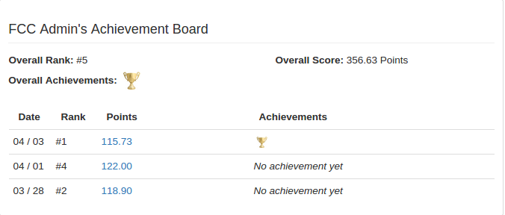

(a)

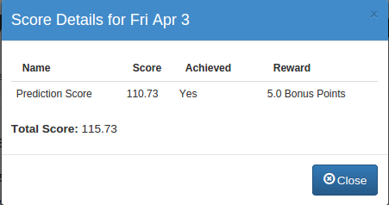

(b)

Figure 4.10. (a) Overall achievement board (b) individual prediction achievement.

4.3 Post-activity

Once the game is completed, the participants only have access to the news board, general rules, their profile related pages, and the final scores and achievements.Figure 4.11 shows the homepage in this stage.

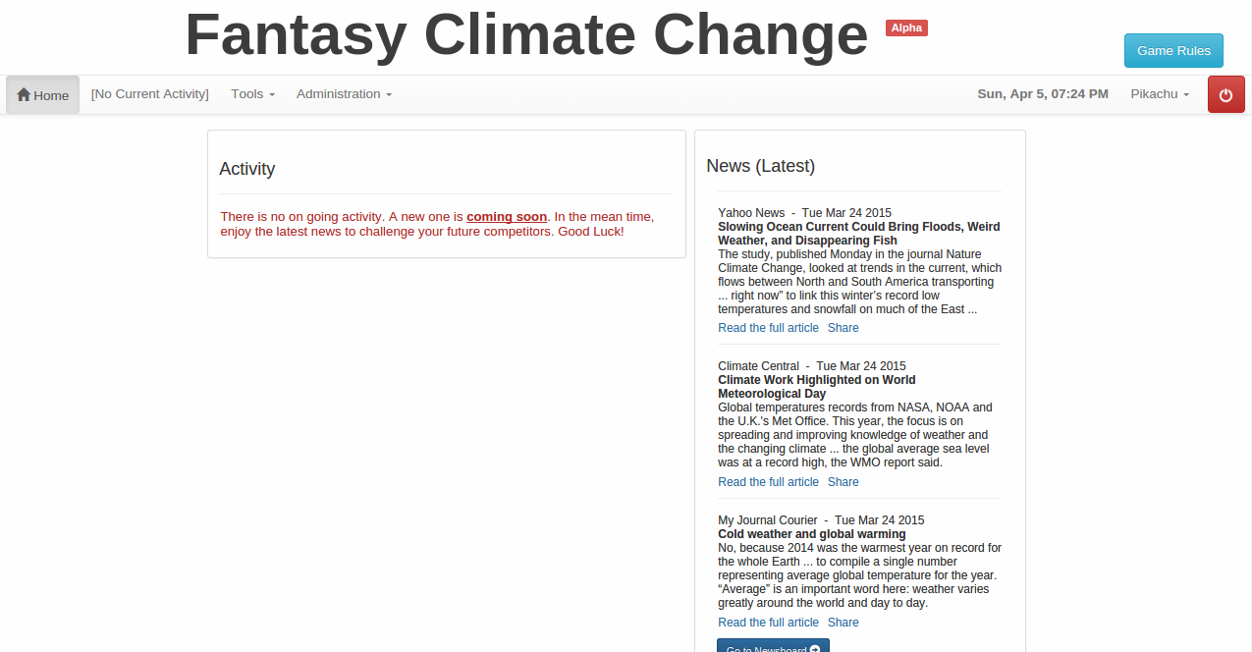

Figure 4.11. Post-activity homepage.

Chapter V  
user study

In order to evaluate the effect of communication systems on engagement within an online education game, a user study was conducted on the Fantasy Climate game. The main aim of the user study was to specifically analyze and investigate asynchronous and synchronous communication within the game and their influence on player commitment. This user study explores the relative value of different modes of communication on player engagement. For this purpose, we invited students from Texas A&M University-College Station who were not involved in the design, development and testing of the Fantasy Climate game.

5.1 Demographics

Overall, 27 users participated in the user study with 14 subjects in one group and 13 subjects in the other. The participants were randomly split into two groups irrespective of their background. We successfully managed to recruit a diverse set of participants from various educational streams (Construction Management, Computer Engineering, Civil Engineering, Electrical Engineering, Computer Science, Petroleum Engineering, Industrial Engineering and Information Technology) at Texas A&M University-College Station. In all, there were 17 males and 10 females in the age range of 18-40 years. Since they were all graduate students, they were expected to have basic knowledge about web browsing, accessing the Internet and simple data analysis. In spite of the Fantasy Climate game and rules being self-explanatory, a video was uploaded on YouTube explaining the various features, tools, prediction rules and necessary information about the in-game links. This acted as a good reference material for the participants in case they faced any obstacle during the game.

5.2 Protocol

The Fantasy Climate game has been hosted on a public domain and a server specifically for this purpose as the game is still in the alpha phase. The game was accessible to the participants throughout the user study at IP address 45.55.163.239 with fantasyclimatechange.com as its canonical name. The participants only needed an active internet connection and an HTML5 enabled web browser to participate in the user study. The study consisted of three steps as mentioned below:

1. Pre-Questionnaire: Firstly, the participants were asked general questions about age, ethnicity and gender. Secondly, questions were asked to gauge their experience and knowledge about fantasy sports and prediction games. Finally, they were asked questions about climate data and their prior data analysis experience.
2. Prediction game: After the pre-questionnaire, all the participants registered in the fantasy climate game. The activity setup in this section explains more about the prediction phases, choosing cities and scoring.
3. Post-Questionnaire: In the final stage, the participants were given a questionnaire to summarize their experience with the game, communication system and identical climate questions as in the pre-questionnaire to explore player learning. However, measuring and exploring learning was not our main focus through this study.

The user study proceeded through three phases. In the first phase, users had access to the asynchronous communication tools during activity prediction. In the second phase they were provided with synchronous communication tools. Finally, all modes of communication were provided to the user in the third phase. Data from usage logs and pre and post-task questionnaires were analyzed to potentially answer the aforementioned research questions regarding engagement and communication.

5.2.1 Timeline

The core of the game was developed flexibly so as to easily maneuver the duration of activity, prediction time and scoring after prediction. The user study lasted for a total of 13 days. Initially, the participants were given two days to familiarize with the game, play around with features provided, read related news and socialize with the competitors. After this, the user study proceeded to have a total of 3 predictions in the active phase each lasting for three days.

The scoring algorithm was scripted to be applied the next day after the due date of each prediction. Finally, to check the participants’ behavior after the activity and post-game communication within the game, we left all the features open to the participants for two days after the last scoring date. Figure 5.1 shows the features and tools provided to the participants during the prediction phases.

To balance the order of exposure to the two communication systems, we split the users into two groups and released different communication systems as shown in Figure 5.1. The same testing methodology as explained earlier was used throughout the user study.

Figure 5.1. User study plan.

5.2.2 City clusters

In order to make the predictions challenging and captivating, the cities available for selection changed in every prediction phase. Figures 5.2, 5.3 and 5.4 show the city clusters chosen for three prediction phases. The selection of the cities were mainly based on geographic distance to provide a better visual and overlay on the map for the players and to ensure a variety of climate zones and current weather.

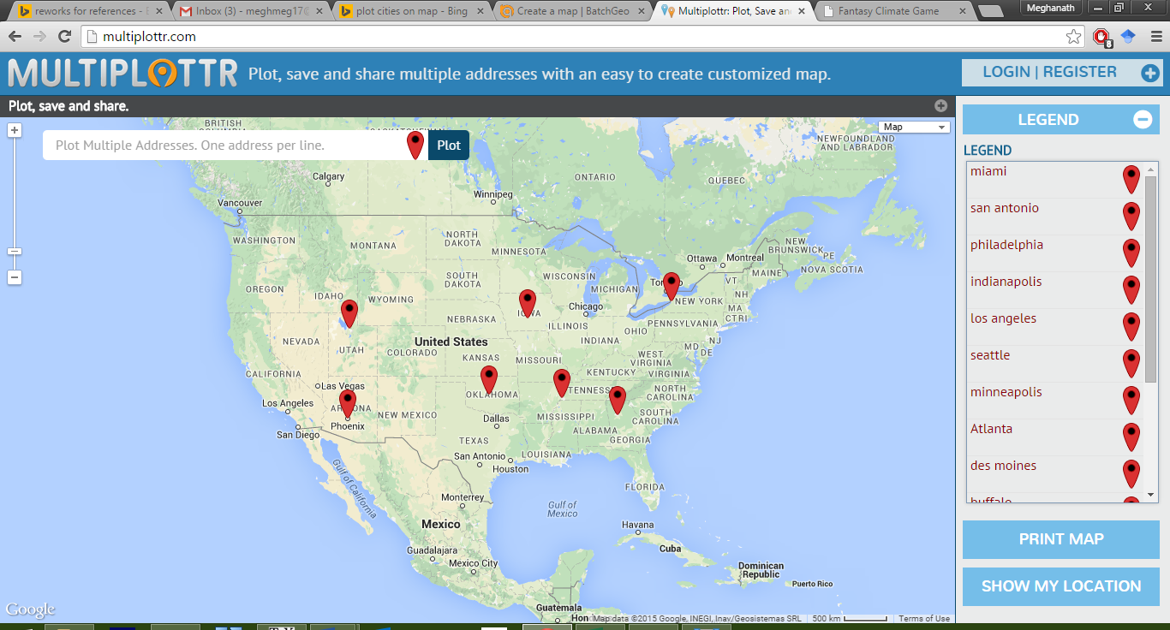

(Phoenix, Oklahoma City, Salt Lake City, Buffalo, Memphis, Des Moines, Atlanta)

Figure 5.2. City cluster 1.

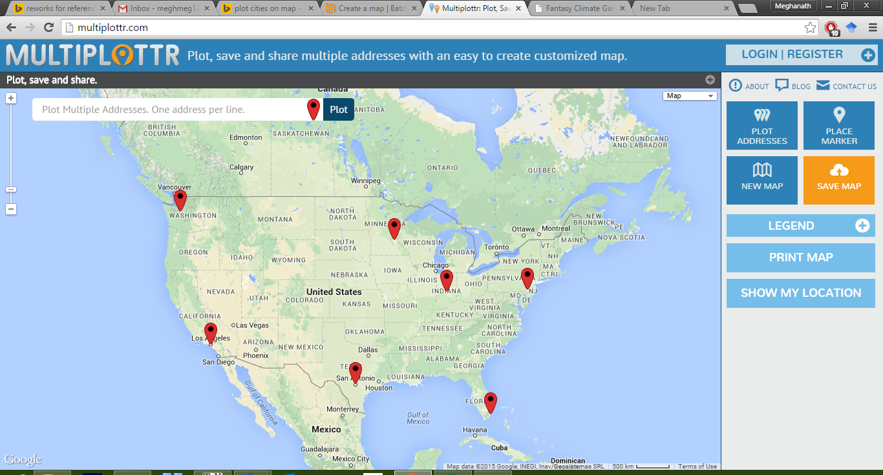

(Miami, Minneapolis, Seattle, San Antonio, Indianapolis, Philadelphia)

Figure 5.3. City cluster 2.

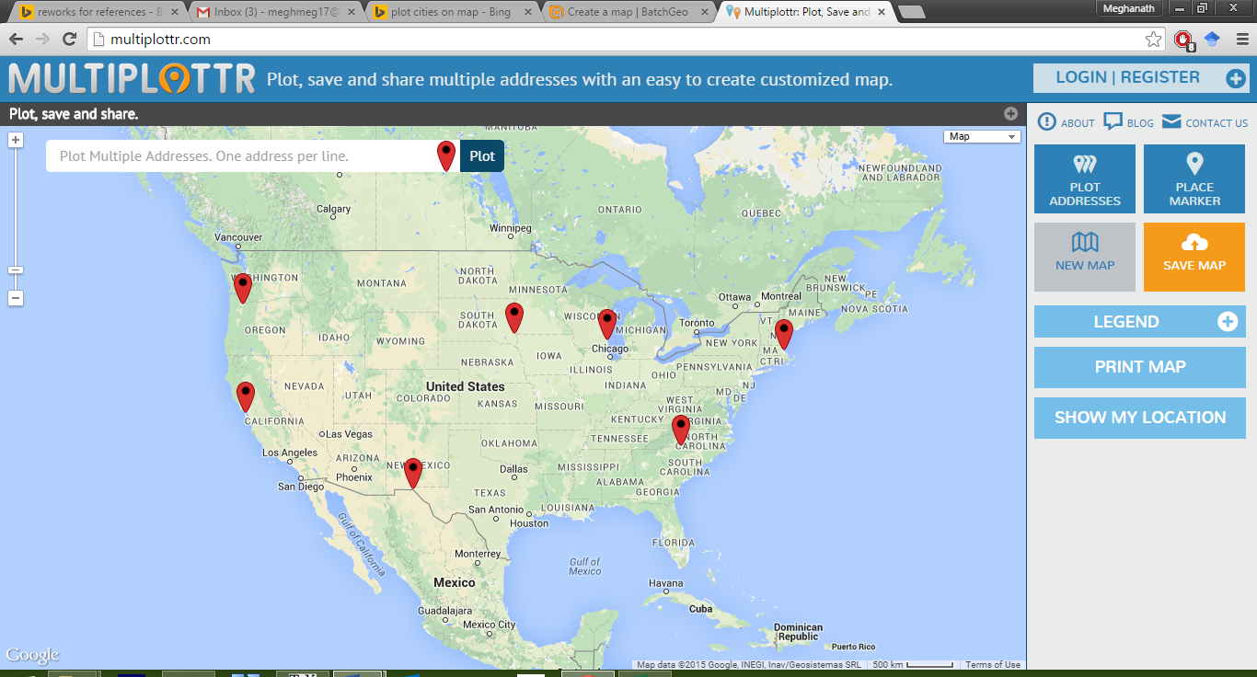

(Portland, San Francisco, Charlotte, Boston, Milwaukee, El Paso, Sioux falls)

Figure 5.4. City cluster 3.

5.3 Web analytics

Analytics is the discovery and communication of meaningful patterns in data. Web analytics is the evaluation, compilation, analysis and reporting of web data in order to understand issues and redesign the web application. In this research, we have used web analytics to garner specific data that measure the players’ engagement with the Fantasy Climate game. For instance, web metrics like page views, session data, average duration and bounce rate depict the interaction of the users with the web application which can be used to measure engagement in our context (Fang 2007, Plaza 2011, Verbert, Duval et al. 2013). Google analytics, a powerful and free web analytics tool has been used in this user study to collect site data at different phases of prediction. For the analytics to work, we pasted a small script into the template that was included in every web page to track the user’s interaction with the web application as a whole. Measures of the exit and entry pages were collected to provide a picture of users’ interaction and of what content(s) interested the users the most (Khoo, Pagano et al. 2008).

Chapter VI  
evaluation and results

6.1 Pre-questionnaire

The main objective behind the pre-questionnaire was to investigate the participants' prior knowledge of and familiarity with fantasy sports. We also asked general questions about climate and communication in games which will be explained later in this section. Irrespective of their knowledge about fantasy sports, all participants were trained on how to play the game and its features. To begin with, we asked the participants about their experience playing fantasy sports, and the hours spent/week if they did. Figure 6.1 shows the responses of participants about the number of years they have played fantasy sports from the pre-questionnaire. Figure 6.2 shows the statistics of the number of hours spent per week.

Figure 6.1. Experience playing fantasy sports in years.

Figure 6.2. Number of hours spent playing fantasy sports in a week.

Out of all the 27 participants who took part in the user study, 7 users had played fantasy sports for less than a year, and 13 of them understood the concept of fantasy sports as they had played for more than a year. Although 7 out of the 27 participants never played fantasy sports, the recruitment training ensured they could easily grasp the rules and the basic idea of the game.

Figure 6.3. Motivation to play games in general.

Consequently, we asked them why do they play and what interests them the most in games. From the responses, it is evident that people play games mainly for the purpose of entertainment, challenge/competition and pass the time. Figure 6.3 shows the stats of motivation behind playing games in general.

Figure 6.4. Users’ interest in following news related to climate/weather.

When asked about social interaction within games, most of the participants reported that they did use some sort of communication system previously. We did not give the participants more information about the communication systems nor ask any related questions purposely in order avoid biased results. Furthermore, we asked the participants if they read/followed news related to climate/weather. Figure 6.4 shows the responses about following news related to climate/weather. As anticipated, most of the participants do read some news related to climate/weather.

A somewhat surprising outcome was that some participants reported following news related to places other than their residence. Some of the reasons as reported by the participants were:

1. Just for the sake of curiosity and also when I need to travel.
2. I do track the weather changes in the cities I've lived earlier. I do not do this out of any other reason than to know how climate varies from place to place.
3. Yes. I keep track of weather of my home city.
4. I track the weather of my home country and a few other cities I have connections with.
5. Relatives living in other cities makes me concerned about the weather there.
6. Yes, for fun.

These responses show that people not only follow weather related news mostly about their permanent residence and other personal interests but also out of concern for their families. From these responses, it can be generalized that people are most likely to follow news about local weather and weather/climate related to the places they live/travel. Finally, participants were asked about their experience with simple data analysis in a gaming context. Of all the 27 participants, only 4 participants reported to have used data analysis tools in a game. Although most of them have never used any data analysis tools in a gaming context, a majority of the participants have experience with data analysis in general. Figure 6.5 shows their experience with simple data analytic activities.

Figure 6.5. Users’ familiarity with simple data analysis.

6.2 Gameplay

Once the pre-questionnaire was completed, the participants registered in the game and played for a duration of thirteen days through five phases: pre-activity, prediction-1, prediction-2, prediction-3 and post-activity. During the recruitment phase, clear but concise instructions were given to them on how to play the game and various other features. In order to avoid affecting the gameplay, we did not give them any information about the communication and data analysis tools in the game.

Some of the metrics used to gauge engagement are defined as follows:

1. **Page views**: This metric shows numbers of times a user visits a page in the web application. As we have separated the communication systems on different pages, page views gives us a good measure of engagement with the game.
2. **Unique page views**: A page can have multiple page visits in a session, but this metric gives unique page views in a single session.
3. **Sessions**: The overall numbers of unique visits to the web application is shown by this metric.
4. **Pages**/**Session**: This metric depicts the numbers of pages visited in a single session.
5. **Average session duration**: The time spent on all the pages in a session is shown by the average session duration.
6. **Average time on pages**: The time on an individual page on an average in shown by this metric.

6.2.1 Evaluation of web-analytics

In order to accurately measure the impact of each communication tool, we divided the population into two groups and started with different communication systems. Data presentation is separated for the two groups to better show what did and what did not affect the results.

6.2.1.1 Asynchronous communication in first prediction

The first group had the asynchronous communication system during the first prediction followed by synchronous phase, and a combination of both in the last phase of prediction. All the figures related to web-analytics have been plotted with the activity phases on the x-axis and respective web-analytics metric on the y-axis. Figure 6.6 shows the page views analytics for group one. There has been considerable number of page visits in the first phase when the asynchronous system was in place, but the page views were reduced during the second phase with the synchronous system in the game. The page views increased a bit when the asynchronous system was brought back into the system.

Figure 6.6. Page views for group-1.

We found that the unique page views also showed a similar trend as the page views. Figure 6.7 shows a similar structure indicating higher engagement when having the asynchronous system. In contrast to the page views and unique page views, the average time spent on pages is relatively flat across the three prediction phases (see Figure 6.8). We speculate that the small increase in the average time spent in the later phases can be attributed to the synchronous nature of chat where users wait for messages while conversing.

Figure 6.7. Unique page views for group-1.

Figure 6.8. Average time on pages in minutes for group-1.

Figure 6.9. Average session duration in minutes for group-1.

The average session duration can be good metric to measure engagement as it shows the amount of time spent with the game in a single session. Again, the average time spent during the first phase having the asynchronous communication was longer than the phase with synchronous communication as shown in Figure 6.9. In addition, the reintroduction of the asynchronous tools increased the average session duration in the final phase demonstrating higher involvement with the game. The total number of sessions and pages/session also reveal more engagement during prediction phase one. Figure 6.10 shows the number of sessions and Figure 6.11 depicts the numbers of pages/session.

Figure 6.10. Number of sessions for group-1.

Figure 6.11. Number of pages/session for group-1.

For this group of participants, the asynchronous communication system seems to have outperformed the synchronous communication in engaging players and increasing commitment. On the other hand, the effect could be due to novelty or learning about the system and domain. In order to discover which communication system performs better from the web-analytics perspective, we need to analyze the game when synchronous communication was released to the participants first. The following subsection shows the evaluation of group two where the synchronous communication system was provided first followed by asynchronous. Finally, the participants have access to the both the social systems similar to group one.

6.2.1.1 Synchronous communication in first prediction

Similar to the earlier web-analytics figures, all the graphs have been plotted with the activity phases on the x-axis and respective web-analytic metric on the y-axis. Firstly, the page views and unique page views show lower visits in the first phase of prediction compared to the second phase. This indicates that players in this group increased game-related activity with the asynchronous communication systems’ presence in the second and third prediction phases. Figure 6.12 shows the page views and Figure 6.13 presents the unique page views.

Figure 6.12. Page views for group-2.

Figure 6.13. Unique page views for group-2.

The average time spent on the pages was highest with the synchronous communication for group two as seen in Figure 6.14. Consequently, average session duration is relatively flat across the three conditions. Finally, the average number of sessions as seen in Figure 6.15 and pages/session as depicted in Figure 6.16 have observed to increase during the existence of asynchronous communication as well.

Figure 6.14. Average time on pages in minutes for group-2.

Figure 6.15. Average session duration in minutes for group-2.

Figure 6.16. Number of sessions for group-2.

Figure 6.17. Number of pages/session for group-2.

In summary, as with group one, there was more activity with asynchronous communication than with synchronous communication. But activity continued to increase when both modes of communication were available. A limitation of this study is that the results were partially a reflection of how well the participants formed a community around the game. It would take considerable further evaluation to examine the relative effects of the groups versus the technology.

6.3 Post-questionnaire

After the participants successfully finished all the phases of the activity, the post questionnaire was given to them. This questionnaire consisted of questions to gauge their overall satisfaction and viewpoint about the communication systems. Also, our inference about the asynchronous system enhancing player experience and engagement from the web-analytics perspective can be validated through the feedback from the participants.

The first three questions were asked to know about their experience using the communication system in the Fantasy Climate game. Moreover, we also wanted to know if the current version of the communication system was capable of information exchange. All of the users either strongly agreed or agreed to this question on the 5-point Likert scale. Next, we asked them if communication within the group motivated them to play longer and increased commitment. Most of the participants agreed to this question except two who responded neutral to this statement.

Furthermore, we asked the participants if communication enhanced the engagement with the game. On the whole, the high averages and low standard deviations show that communication is viewed as valuable in the context of prediction games. The statistical data of the participants’ rating of the communication questions is shown in Table 6.1. Figure 6.18 shows the overall responses of the participants about communication system and its effect on engagement.

|  |  |  |
| --- | --- | --- |
|  | **Average** | **Standard Deviation** |
| Communication with other members of the group is essential for information exchange. | 4.37037 | 0.629294 |
| Having social or communication tools (tools that provide interaction between individuals within the game) helps engagement with the game. | 4.481481 | 0.509175 |
| Communication with members increased commitment to the Prediction game. | 4.37037 | 0.629294 |
| I used the in-built tools (news board, thermovizz) to learn about the domain before prediction? | 4.20012 | 0.7800641 |

Table 6.1. Participants’ rating of the overall communication system based on a Likert scale (1 to 7).

Finally, we asked participants about the built-in news and analysis tools. Most if the participants liked the built-in tools and the simple user interface, but some of the participants reported using other resources for prediction. The responses of the participants are summarized in appendix-2. The feedback from the participants has been recorded and will be used to improve the system in the future.

Figure 6.18. Participants’ responses about overall communication system based on a likert scale (1 to 5).

After asking about the communication general, participants were asked about particular modes of communication. To start with, we asked the participants about the forum. Although some of the participants reported that they did not contribute to the forum, most reported following it regularly and looking out for information regarding the game. Figure 6.19 shows the responses of the participants’ experience with the forum. There was a positive response when asked about the asynchronous nature of the forum. The participants stated that the forum was very efficient in making interaction possible with their competitors at their convenience.

Figure 6.19. Participants’ experience with the forum based on a likert scale (1 to 5).

Secondly, the participants were asked about the role of message board during the prediction phases. Although the responses show that it has not been as engrossing as the forum, the participants expressed their satisfaction using the message board and reported it as a useful means for rapid information exchange in the game. It has been mainly used to announce important news to the whole group and to ask quick questions. Figure 6.20 shows the overall participants’ responses using the message board.

Thirdly, we asked the participants about their experience and usage of the direct messages. The responses indicate that the direct messages has been the least absorbing feature amongst all of the asynchronous communication systems. This shows that privacy was not an issue in the educational games with asynchronous communication though the participants did not know each other. Moreover, the responses show that the participants were comfortable facing the whole group of fantasy players through the forums and message boards.

Figure 6.20. Participants’ experience with the message board based on a likert scale (1 to 5).

Direct messages between players were also used as a mean to send notifications within the game about various deadlines and updates. Figure 6.21 show the participants’ responses about the direct messages.

Figure 6.21. Participants’ experience with the direct messages based on a likert scale (1 to 5).

Figure 6.22. Participants’ experience with the chat based on a likert scale (1 to 5).

Finally, after answering questions about asynchronous system, the participants were asked about the synchronous communication system. The results seen in Figure 6.22 were inclined towards the neutral or lower on the Likert scale. The responses show that the chat system was not as successful as the asynchronous system for exchanging information and ideas. Moreover, some of the users also reported that chatting with strangers was awkward and difficult. Hence, the flow in the game was disturbed only having the synchronous system as they could not converse efficiently.

After observing that all of the asynchronous tools were better liked by the participants and reported to have enhanced engagement, the asynchronous tools were compared. From the Figure 6.23, it is evident that the forum was viewed as more engaging tool than the message board and direct messages. At the end of the survey participants gave suggestions about the game, bugs, features they liked and disliked. Appendix-2 shows their responses. Overall, the responses indicated that the participants liked the game and the idea of prediction games.

Figure 6.23. Overall comparative analysis of forum, message board and direct messages.

Besides user perceptions of the different modes of communication, we can analyze the quantity and characteristics of such communication that took place during the study. To examine this data, we removed all communication involving the game administrators as our focus was on how communication with other players affects engagement.

The left part of Figure 6.24 shows the number of messages sent between participants in the game for each mode of communication. In terms of number of messages, the synchronous system had as many as all the synchronous messaging mechanisms combined. Most of the chat’s messages were shorter in length which is evident in the right part of Figure 6.24 which shows the number of words in the communications in the various modes of communication. This data shows that communication in the forum was the most substantial in terms of overall length and in terms of average length per communication.

(a) (b)

Figure 6.24. Activity in terms of (a) number of messages and (b) number of words on the communication systems.

Knowing what type of communication happens in each communication mode can help understand player activity. Figure 6.25 shows the different types of interactions categorized into prediction/game related, greetings, trash talking and system related. Analysis shows that although the synchronous communication (chat) has the highest activity according to the number of messages, many of these messages were greetings/acknowledgements between the participants. In contrast, elaborate messages and explanations were observed in case of the Forum. It was noticed that participants often exchanged information about the game and technicalities related to the system on the asynchronous system. These results show that the Forums were used for in-depth discussions to share technical expertise about the game. Message boards were used for rapid questions and announcements in the game. Finally, casual and trash talking were common on the chat, but were unlikely on the asynchronous communication system.

Figure 6.25. Type of messages on the communication systems.

Chapter VII  
Conclusion and future DIRECTION

Data prediction games have the potential to be engaging environments that educate, entertain and inform. Moreover, they emphasize the development of data interpretation skills and mental models of the domain and can be developed for any domain with real-time and historical data to nurture engagement and learning about the domain. Fantasy sports, which combine historical data on athletes’ performances with real-time data generated from live sports events are a subset of prediction games.

Many games are or involve a social activity. It is well known that they nurture collaboration and players use one form of communication or the other while games playing to interact with their allies or competitors. However, little is known about which mode of communication increases involvement with the prediction games. In this thesis, I investigated asynchronous and synchronous communication and their influence on player engagement in the context of Fantasy Climate game.

An evaluation of the Fantasy Climate game and its features was conducted. The participants found the asynchronous communication system to have better served their need of information exchange over the synchronous communication in the context of prediction games. Additionally, the forum has engaged the participants efficiently and promoted social interaction as seen through user ratings of the communication tools. The page views, unique page views, sessions, average session duration and pages/session have been higher during the presence of asynchronous communication, especially the forum. This is further confirmed by the participants’ responses from the post questionnaire. In conclusion, the analysis of data from the web-analytics and evaluation of the participants’ responses illustrate that asynchronous communication, specifically via a forum, provides a rich social environment enhancing player experience and enjoyment. The inclusion of communication tools in educational games encourage social activity, thereby providing new learning methodologies and increasing commitment towards the game.

As some of the participants reported that privacy was an issue when using the synchronous communication, the game could be played in a classroom or with a group of people who know each other to see if the effectiveness of the chat increases in such situations.

References

Andresen, M. A. (2009). "Asynchronous Discussion Forums: Success Factors, Outcomes, Assessments, and Limitations." Educational Technology & Society 12(1): 249-257.

Antin, J. and E. F. Churchill (2011). Badges in social media: A social psychological perspective. CHI 2011 Gamification Workshop Proceedings (Vancouver, BC, Canada, 2011).

Boswell, J. (2007). "Fantasy sports: A game of skill that is implicitly legal under state law, and now explicitly legal under federal law." Cardozo Arts & Ent. LJ 25: 1257.

Bradshaw, J. and L. Hinton (2004). "Benefits of an Online Discussion List in a Traditional Distance Education Course." Online Submission 5(3).

Brown, E. and P. Cairns (2004). A grounded investigation of game immersion. CHI'04 extended abstracts on Human factors in computing systems, ACM: 1297-1300.

Burns, R. B. (1991). "Study and stress among first year overseas students in an Australian university." Higher Education Research and Development 10(1): 61-77.

Charles, D., et al. (2005). Player-centred game design: Player modelling and adaptive digital games. Proceedings of the Digital Games Research Conference. 285: 00100.

Consalvo, M. (2011). Using your friends: social mechanics in social games. Proceedings of the 6th International Conference on Foundations of Digital Games, ACM: 188-195.

Cordova, D. I. and M. R. Lepper (1996). "Intrinsic motivation and the process of learning: Beneficial effects of contextualization, personalization, and choice." Journal of educational psychology 88(4): 715.

Dabbish, L., et al. (2012). Communication and commitment in an online game team. Proceedings of the SIGCHI conference on human factors in computing systems, ACM: 879-888.

Davies, J. and M. Graff (2005). "Performance in e‐learning: online participation and student grades." British Journal of Educational Technology 36(4): 657-663.

Dzodom, G. S. and F. M. Shipman (2014). Data-driven web entertainment: the data collection and analysis practices of fantasy sports players. Proceedings of the 2014 ACM conference on Web science, ACM: 293-294.

Fang, W. (2007). "Using Google Analytics for improving library website content and design: A case study." Library Philosophy and Practice 9(2): 22.

Fox, C. M. and J. H. Brockmyer (2013). "The Development of the Game Engagement Questionnaire: A Measure of Engagement in Video Game Playing: Response to Reviews." Interacting with Computers: iwt003.

Gajadhar, B. J., et al. (2008). Shared fun is doubled fun: player enjoyment as a function of social setting. Fun and games, Springer: 106-117.

Garcia, A. C. and J. Baker Jacobs (1999). "The eyes of the beholder: Understanding the turn-taking system in quasi-synchronous computer-mediated communication." Research on language and social interaction 32(4): 337-367.

Garris, R., et al. (2002). "Games, motivation, and learning: A research and practice model." Simulation & gaming 33(4): 441-467.

Guldberg, K. and R. Pilkington (2007). "Tutor roles in facilitating reflection on practice through online discussion." Educational Technology & Society 10(1): 61-72.

Habgood, M. J. and S. E. Ainsworth (2011). "Motivating children to learn effectively: Exploring the value of intrinsic integration in educational games." The Journal of the Learning Sciences 20(2): 169-206.

Handel, M. and J. D. Herbsleb (2002). What is chat doing in the workplace? Proceedings of the 2002 ACM conference on Computer supported cooperative work, ACM: 1-10.

Hew, K. F., et al. (2010). "Student contribution in asynchronous online discussion: A review of the research and empirical exploration." Instructional Science 38(6): 571-606.

Holleman, M. C. (2006). "Fantasy football: Illegal gambling or legal game of skill." NCJL & Tech. 8: 59.

Hum, N. J., et al. (2011). "A picture is worth a thousand words: A content analysis of Facebook profile photographs." Computers in Human Behavior 27(5): 1828-1833.

Isaacs, E., et al. (2002). The character, functions, and styles of instant messaging in the workplace. Proceedings of the 2002 ACM conference on Computer supported cooperative work, ACM: 11-20.

Kappen, D. L., et al. (2013). "Exploring Social Interaction in Co-located multiplayer games." CHI'13 Extended Abstracts on Human Factors in Computing Systems: 1119-1124.

Khoo, M., et al. (2008). Using web metrics to analyze digital libraries. Proceedings of the 8th ACM/IEEE-CS joint conference on Digital libraries, ACM: 375-384.

Mandryk, R. L. and K. M. Inkpen (2004). Physiological indicators for the evaluation of co-located collaborative play. Proceedings of the 2004 ACM conference on Computer supported cooperative work, ACM: 102-111.

Manninen, T. (2003). "Interaction forms and communicative actions in multiplayer games." Game studies 3(1): 2003.

McClelland, P. J., et al. (2011). Investigating communication and social practices in real-time strategy games: are in-game tools sufficient to support the overall gaming experience? Proceedings of Graphics Interface 2011, Canadian Human-Computer Communications Society: 215-222.

McDaniel, R., et al. (2012). Using badges for shaping interactions in online learning environments. Professional Communication Conference (IPCC), 2012 IEEE International, IEEE: 1-4.

Nandi, D., et al. (2011). How active are students in online discussion forums? Proceedings of the Thirteenth Australasian Computing Education Conference-Volume 114, Australian Computer Society, Inc.: 125-134.

Nardi, B. and J. Harris (2006). Strangers and friends: Collaborative play in World of Warcraft. Proceedings of the 2006 20th anniversary conference on Computer supported cooperative work, ACM: 149-158.

O’Donovan, S. (2012). "Gamification of the games course." Acesso em 17.

Oliver, R. and A. Omari (2001). "Student responses to collaborating and learning in a web‐based environment." Journal of Computer Assisted Learning 17(1): 34-47.

Olson, C. K. (2010). "Children's motivations for video game play in the context of normal development." Review of General Psychology 14(2): 180.

Pieterse, V. and I. J. van Rooyen (2011). Student discussion forums: What is in it for them? Computer Science Education Research Conference, Open Universiteit, Heerlen: 59-70.

Plaza, B. (2011). "Google Analytics for measuring website performance." Tourism Management 32(3): 477-481.

Rohit, G. (2013). Weather Data Gamification. Texas A & M University, Texas A & M University. Master's thesis.

Rovai, A. P. (2002). "Building sense of community at a distance." The International Review of Research in Open and Distributed Learning 3(1).

Ruihley, B. J. and R. L. Hardin (2011). "Message boards and the fantasy sport experience." International Journal of Sport Communication 4(2): 233-252.

Schoenau-Fog, H. (2011). The player engagement process–An exploration of continuation desire in digital games. Think Design Play: Digital Games Research Conference.

Selnow, G. W. (1984). "Playing videogames: The electronic friend." Journal of Communication 34(2): 148-156.

Shipman, F. M. (2009). Blending the real and virtual in games: the model of fantasy sports. Proceedings of the 4th International Conference on Foundations of Digital Games, ACM: 169-174.

Verbert, K., et al. (2013). "Learning analytics dashboard applications." American Behavioral Scientist: 0002764213479363.

Woo, C. W., et al. (2008). "Sports PR in message boards on Major League Baseball websites." Public Relations Review 34(2): 169-175.

Xu, Y., et al. (2011). Sociable killers: understanding social relationships in an online first-person shooter game. Proceedings of the ACM 2011 conference on Computer supported cooperative work, ACM: 197-206.

Yee, N. (2006). "Motivations for play in online games." CyberPsychology & behavior 9(6): 772-775.

appendix-1

HEURISTIC EVALUATION QUESTIONNAIRE

**Post Questionnaire**

**Evaluation of the Fantasy Climate Change game**

**Questions related to evaluation of the communication system in general**

1. Communication with other members of the group is essential for information exchange.

1 2 3 4 5

Strongly Disagree Disagree Neutral Agree Strongly Agree

1. Communication with members increased commitment to the Prediction game.

1 2 3 4 5

Strongly Disagree Disagree Neutral Agree Strongly Agree

1. Having social or communication tools (tools that provide interaction between individuals within the game) helps engagement with the game

1 2 3 4 5

Strongly Disagree Disagree Neutral Agree Strongly Agree

1. Which feature played an important role in keeping you engaged and maintained the flow with the game (activity prediction)? (Select all that apply)

* Chat
* Forum
* Message Board
* Direct Messages

1. I used the in-built tools (News board, Thermovizz) to learn about the domain before prediction.

1 2 3 4 5

Strongly Disagree Disagree Neutral Agree Strongly Agree

1. Have you used any others resources other than the ones provided in the game for prediction? If yes, please explain.

_________________________________________________________________________________________________________________________________________________________________________________

1. Any other comments/feedback?

_________________________________________________________________________________________________________________________________________________________________________________

**Questions related to evaluation of the synchronous communication system**

**Chat System**

1. Chat system was influential in exchanging ideas and information during prediction.

1 2 3 4 5

Strongly Disagree Disagree Neutral Agree Strongly Agree

1. Chat system keeps me engrossed in the game.

1 2 3 4 5

Strongly Disagree Disagree Neutral Agree Strongly Agree

1. I sometimes lost track of time when chatting with users.

1 2 3 4 5

Strongly Disagree Disagree Neutral Agree Strongly Agree

1. Chatting with strangers to exchange ideas was awkward and uneasy.

1 2 3 4 5

Strongly Disagree Disagree Neutral Agree Strongly Agree

1. I played longer than I wanted having the Chat feature of communication in the system.

1 2 3 4 5

Strongly Disagree Disagree Neutral Agree Strongly Agree

1. Did the chat system play an essential role in information exchange thereby keeping you engaged with the game? Why? Please explain.

_________________________________________________________________________________________________________________________________________________________________________________

**Questions related to evaluation of the asynchronous communication system**

**Forum**

1. I followed the threads on the forum regularly.

1 2 3 4 5

Strongly Disagree Disagree Neutral Agree Strongly Agree

1. I contributed to the threads on the forum.

1 2 3 4 5

Strongly Disagree Disagree Neutral Agree Strongly Agree

1. Forum helped me interact with users in convenience with my schedule.

1 2 3 4 5

Strongly Disagree Disagree Neutral Agree Strongly Agree

1. Forum discussion absorbed me into the game.

1 2 3 4 5

Strongly Disagree Disagree Neutral Agree Strongly Agree

1. I played longer than I meant having the Forum feature of communication in the system.

1 2 3 4 5

Strongly Disagree Disagree Neutral Agree Strongly Agree

1. Did the forum play an essential role in information exchange and thereby keeping you engaged with the game? Why? Please explain.

_________________________________________________________________________________________________________________________________________________________________________________

**Message Boards**

1. I logged in the game only to check the message boards.

1 2 3 4 5

Strongly Disagree Disagree Neutral Agree Strongly Agree

1. Message Boards kept me involved with the game although asynchronous.

1 2 3 4 5

Strongly Disagree Disagree Neutral Agree Strongly Agree

1. I played longer than I meant having the Message Board feature of communication in the system.

1 2 3 4 5

Strongly Disagree Disagree Neutral Agree Strongly Agree

1. Did the message boards play an essential role in information exchange and thereby keeping you engaged with the game? Why? Please explain.

_________________________________________________________________________________________________________________________________________________________________________________

**Direct Messages**

1. I checked my direct messages regularly and it was good way to exchange information privately.

1 2 3 4 5

Strongly Disagree Disagree Neutral Agree Strongly Agree

1. I played longer than I meant having the Direct Messages feature of communication in the system.

1 2 3 4 5

Strongly Disagree Disagree Neutral Agree Strongly Agree

1. Did direct messages play an essential role in information exchange and thereby keeping you engaged with the game? Why? Please explain.

_________________________________________________________________________________________________________________________________________________________________________________

appendix-2

HEURISTIC EVALUATION COMMENTS AND SUGGESTIONS

**Overall Fantasy Climate Change Game Evaluation Summary**

**Have you used any others resources other than the ones provided in the game for prediction? (Summary)**

* I used a few links posted on the message boards for prediction. They were related to monthly weather forecasts.
* I've used the website weather.com and several other weather forecasting websites apart from the tools provided in this game to get the data for the past few weeks.
* No. The ones provided were good enough.
* No I used just the tools provided in the game.
* I used the internet to compare between latest temperature trends of any two selected cities. Also some of the links posted on forums and message boards led to external sources.
* The weather forecast data is available online. I used weather.com and google weather to browse through the weather articles to learn about climate changes.This really helped in prediction.
* No, other than general knowledge.
* Yes. I used R software for the first prediction but later on I followed some simple techniques such as observing the weather forecast for the past days and also following weather predictor.
* I have used other websites like accuweather for perfect predictions.
* Yes. Mostly Google Weather.
* Weather prediction reports online.

**Any other comments/feedback?**

* This is a very good game - one of its kind. I have always played fantasy games related to sports but never got a chance to play something like this. I am glad and I really would like to thank the admin for giving me a chance to play this game.
* It has been a great experience playing this game. I really appreciate the creator for the time and effort he has put in creating this wonderful thing. It has not just been a game but also a good learning experience for people who never had any experience using the analytical tools and predictions. Overall, it has been a wonderful experience and a great job done!
* I appreciate the developers of this game for putting forth and interesting game that involves social interaction. However, I strongly feel there is scope for improvement as always. The following areas could be addressed:Explanations to answers could be provided post prediction, more data analysis tools, option to export data into workable formats (e.g. *.xls). These are just a few suggestions but I thoroughly acknowledge the amount of effort and skill that went into creating the game. Kudos!
* In my opinion, if the game is really played in a competitive spirit (i.e. the winner gets huge cash prize), the communication tools will be used mostly for tech support. I would personally not discuss my strategy and taking the risk of reducing my chances to win!!
* The game was intuitive but better tools would have made it more interesting.
* Website was very user-friendly, great work!
* Greater data should have been provided to increase higher discussion rate.
* Greater data should have been provided to increase higher discussion rate.
* The game was exciting and the in-built social and communication tools ensured that users are engrossed in the game throughout.
* The news board showed unrelated stuff for most part of the game.
* The game features can be expanded to make it more interesting**.**

**Overall Synchronous Communication Evaluation**

**Chat**

**Did the chat system play an essential role in information exchange thereby keeping you engaged with the game? (Summary)**

* Yes, interacting with the other players developed a healthy competition which kept me engaged throughout.
* Chat system wasn't influential in exchanging ideas. It was not common for users to be online at the same time. Also trying to initiate chat with unknown users felt awkward.
* Yes. I believe that chat system was very useful in exchanging ideas with others and getting inputs from them too. These kind of chat communicating systems must be included for effective performance of a player.
* The chat was engaging because anything that needed to be clarified was done easily within minutes, rather than waiting for people to reply to forum messages.
* Honestly, I'm not a great fan of chatting on social media. However, this being a fantasy game where people were competing with each other, the chat option intrigued me as to how much information could be exchanged. Though my usage of this feature was limited, it was an important tool to know new people and their thoughts on the game. But I'd say chat feature was not key in keeping me engaged in the game.
* Not really. With limited number of users and them being strangers, the chat system was not really helpful. Furthermore, not many users were online at the same time.
* Yes. It helped in proper communication of predictions and its discussion with the peers.
* Yes! The chat system was vital for exchange of ideas and information. We know something which others do not know and vice versa, so it was really helpful for keeping me engaged with the game.
* Yes. The chat feature helped interact with the other users and discuss about the features and tools available to improve the prediction.
* Not really. No users were online when I logged in.

**Overall Asynchronous Communication Evaluation**

**Forum**

**Did the Forum play an essential role in information exchange thereby keeping you engaged with the game? (Summary)**

* Yes, helped in improving my predictions taking in the information provided by other players in regards to the various methods they used for prediction.
* I felt forum was the most important means of communication. Each user could read posts on what one is specifically looking for.
* Yes. As mentioned earlier, I thought forum is an effective platform for people to discuss about their ideas, methodologies and any useful information they'd like to share with the other players.
* It's like the forum was always active with posts from everybody. This made the game more interesting for sure.
* Yes, there were some interesting discussions on the methods one could apply to assess information correctly. Also, it helped to analyze what was written at our convenience.
* Just like the message boards, the forums also played the same role.
* Yes, forum I think is one of the highlights of this game. The players were able to post their questions and get the other players answer them. It was a two way communication and was very helpful in making some major decisions on the game.
* Forum was the best part of player interaction in this game. There were many constructive discussions and quality information was shared from people of varied backgrounds. Though there was the risk of digression as some people got carried away with data analysis techniques, often times the participants stuck to topic and shared ideas worth knowing. Hence, I would forum was instrumental in keeping me engaged in the game.
* Yes, it did. Looking at recent posts was interesting and made me want to play the game more seriously.
* Forums are the best way to bring out ideas/ views from different people. They play an important role in information exchange and knowledge sharing.
* Forums were helpful in having discussions as a group and know others views.
* Yes, the discussions in the forum helped us to think of other ways to predict the data by using different other statistical methods.
* Yes. It helped me understand the game initially and using the tools in a better manner.
* Probably the best medium for information exchange at least for this game in the current context.

**Message Board**

**Did the Message Board play an essential role in information exchange thereby keeping you engaged with the game? (Summary)**

* Message board was critical in conveying a piece of information to all the users at one go. I was always monitoring the message board for any specific links that would have helped me with my prediction.
* Honestly, I couldn't find much difference between thread and message boards. I might be wrong here, but honestly, I didn't see if it's of any value-add to this game.
* It's like the message boards helped us clarify any doubts that we had and kept the game interesting and lively.
* Message boards had some interesting ideas being discussed which were engaging.
* Message boards did play an important role in keeping me involved. Many co-players shared decent articles and information though the message board initially was a dormant affair. In a nutshell, message board was effective but not as instrumental as forums.
* Message boards were helpful scenarios where Admins had to post some updates.   
  Also, it was useful in the beginning of the game when players were still figuring out the available tools to post quick updates.
* I checked them for information.
* Definitely yes. Exchange of ideas and creativity was exchanged during these conversations and we got to learn a lot from others as well.
* Yes. They helped me in thinking what the other users' perspective was.
* Yes, I thought the discussions were very relevant and the discussion of techniques was useful.
* Yes it did keep me engaged in the game. It helped in communicating with different people resulting in exchange of different views and perspectives regarding prediction.
* Message boards were not as helpful as chat messages. I felt that Chat messages are more interactive and more personalized.
* Yes, they helped us to exchange ideas that might help to increase the accuracy of the predictions.

**Direct Messages**

**Did the Direct Messages play an essential role in information exchange thereby keeping you engaged with the game? (Summary)**

* Direct messaging was a little helpful over the chat feature as I felt it was a more formal means of communicating with unknown users.
* Yes, they did. If someone had a personal question or any other query meant to only one person, direct message is a good way of reaching out to the person as it is something which is not public.
* It's like the direct messages were a convenient way for us to contact others privately. I think there should be both options: to post on a public forum and to be able to send private messages.
* It didn't play an essential role, but there would surely be scenarios where it would have. For example if the interface was a little complex and had features that were too many, the chat system would allow users to take help instantly and get used to the game sooner.
* Yes, direct messages were helpful in transferring the information, rules and announcements from the admin to the players.
* To me, the direct message did not play a major role in keeping me involved. I was rather interested in group discussions where my thoughts and opinions reached a larger section of players. The only takeaway from this was the messages I was getting from Fantasy Climate administrator informing me about the deadlines and changes.
* Yes it kept me informed of the deadlines.
* Yes! Whenever I forgot to predict on a particular given day, I used to get an alert to fill out the prediction. This kept me engaged with the game
* Not really, because the forum feature is good enough to exchange ideas. The direct message feature is an additional tool that distracts the players.
* It was good to have the direct messages. But I did not use them to be engrossed in the game. Message boards and forums gave better information.
* Direct messages were very helpful. Constant reminders about the predictions helped in keeping a track of the submissions.
* The direct messages helped us to exchange ideas that had an important role in predicting the weather using the past data.